### **Chapter 2: Understanding Traffic Laws, Signals, Markings, and Intersections**

Traffic laws, signals, and markings form the foundation of safe, lawful, and efficient driving. These guidelines ensure smooth traffic flow, minimize collisions, and provide clear expectations for all road users. This chapter covers why these rules exist, how they work, and how to apply them correctly.

### **The Importance of Traffic Laws**

#### **1. Reasons for Traffic Laws**

**Safety**:  
Traffic laws are designed to protect everyone—drivers, pedestrians, cyclists, and passengers. Rules such as seat belt requirements, speed limits, and DUI laws are proven to save lives and reduce injuries.

### **In the United States:**

* An estimated **39,345 people died** in motor vehicle crashes in 2024—a **3.8% decrease** from 2023’s 40,901 fatalities (NHTSA, 2025).
* The **fatality rate** dropped to **1.20 deaths per 100 million vehicle‑miles traveled**, the lowest rate since 2019 (NHTSA, 2025)

### **In Florida:**

* Florida recorded an estimated **3,188 traffic fatalities** in 2024, a **6.1% decrease** from the estimated 3,396 fatalities in 2023 (NHTSA, 2024).
* The projected **traffic fatality rate per 100 million vehicle-miles traveled** declined from **1.46 in 2023 to 1.36 in 2024**, indicating a small improvement in risk (NHTSA, 2024)

**Reducing Societal Impacts**:  
Traffic crashes cause more than just physical harm—they lead to emotional trauma, financial burdens, and societal costs such as repairs and wasted time and fuel. Preventable collisions also impact emergency services and healthcare systems. By driving responsibly, we reduce these far-reaching consequences.

**Preventing Congestion**:  
Violations like running red lights or blocking intersections can cause traffic jams that last for hours. Cooperation and adherence to traffic laws help keep roads flowing smoothly.

#### **2. Common Understanding**

**Uniformity on the Roads**:  
Public education campaigns and standardized traffic laws create predictability. Drivers understand how to respond to stop signs, yield signs, and right-of-way rules, fostering safer interactions on the road.

#### **3. Anti-Gridlock Law**

The anti-gridlock law prohibits entering an intersection unless you can clear it entirely. Blocking intersections creates unnecessary delays and dangers.

This law is outlined in **Florida Statute 316.2061**, which emphasizes keeping intersections clear to maintain traffic flow and safety. Always ensure there is enough space ahead before proceeding into an intersection.

### **Traffic Signals: What They Mean**

Traffic signals communicate when to stop, go, or proceed with caution. They communicate right of way, but they don’t guarantee safety when proceeding, so awareness is always required. Following their instructions is mandatory under **Florida Statute 316.075.** Previously, you may have disregarded traffic signals, which is unsafe for you and other drivers. This traffic signal refresher will help you identify driving habits that may have caused you problems.

**CLICK TO LEARN ABOUT THE TRAFFIC SIGNAL**

|  | **Red Light**: Stop completely before the crosswalk or intersection. Do not proceed until the light turns green and the way is clear. |
| --- | --- |
| **Yellow Light**: A warning that the signal is about to turn red. Drivers should slow down and prepare to stop unless stopping would be unsafe. Never accelerate to "beat" the light. |  |
|  | **Green Light**: Indicates "go," but proceed only when the intersection is clear of pedestrians, bicycles, and vehicles. |

## **Scenario: “I Thought I Had Time”**

**Situation:** Danielle describes herself as a “decisive” and “efficient” driver. She doesn’t like waiting — especially at lights. One afternoon, she’s approaching an intersection when the light turns yellow. She’s about 150 feet away, going 40 mph. She tells herself, “If I speed up a little, I can make it.”  
 She presses the gas. As she enters the intersection, the light turns red. A driver from the cross street has already started to go. Danielle swerves to avoid a collision and barely misses a pedestrian who stepped off the curb.

### **What Went Wrong?**

Danielle didn't “run” a red light — but she **misjudged the risk** of squeezing the yellow. Her choice wasn’t just about timing — it was about **emotions**:

* **Impatience** with stopping,
* **Overconfidence** in her judgment,
* **Desire for control** over the flow of her day.

These traits behind the wheel can **lead to life-threatening decisions**.

### **The Bigger Picture:**

* More than **40% of crashes** involving traffic signals occur at intersections where someone tried to beat a yellow (NHTSA, 2023).
* **Pedestrians and cross-traffic** often assume red-light runners won’t come through — putting others at risk when someone miscalculates.

### **Reflection Questions:**

* Have you ever “pressed through” a yellow light?
* Were you doing it to save time — or to avoid feeling slowed down?
* What could have happened if Danielle had stopped?

### **Commitment Pledge:**

*I pledge to treat yellow lights as a signal to* ***slow down and prepare to stop****, not speed up. I will recognize when impatience or pride influences my choices, and choose safety — even if it means waiting 30 more seconds.*

**✓ CLICK TO COMMIT**

#### **Arrows and Flashing Signals**

**CLICK TO LEARN ABOUT THE TRAFFIC SIGNAL**

|  | **Red Arrow**: Stop and wait for a green arrow or signal before making a turn. |
| --- | --- |
| **Yellow Arrow**: Alerts drivers turning that cross traffic will soon begin moving. Prepare to stop or proceed cautiously. |  |
|  | **Green Arrow**: Allows for a "protected" turn in the direction of the arrow while cross traffic is stopped. |
| **Flashing Red**: Operates as a stop sign; drivers must come to a complete stop and yield before proceeding. |  |
|  | **Flashing Yellow**: Warns drivers to slow down and exercise caution, often indicating a potential hazard ahead. |
| **Traffic Signal Blackout:** Treat as a all-way stop & be courteous. |  |

#### **Dealing with Malfunctioning Traffic Signals**

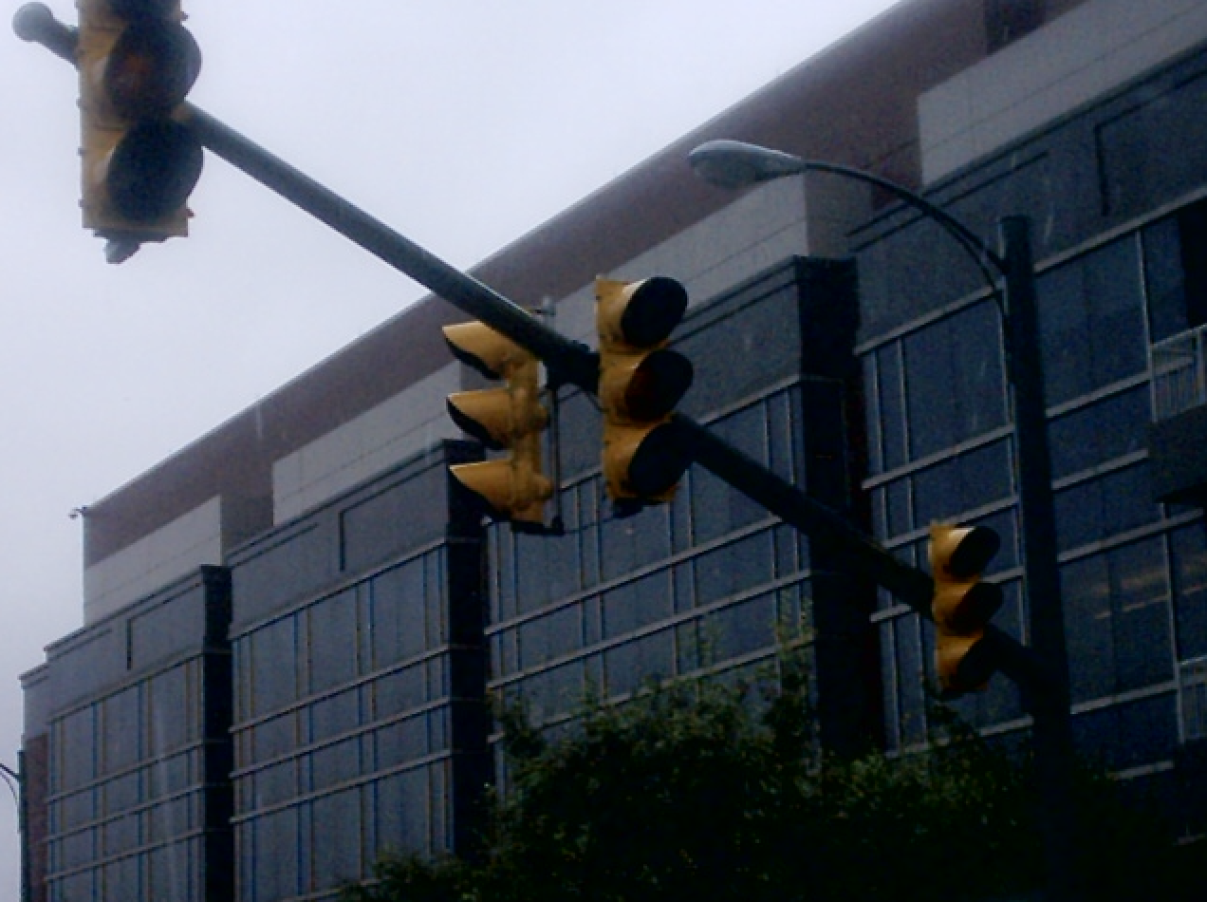

When traffic signals are not functioning, it is critical to handle the situation safely and lawfully. According to **Florida Statute 316.1235**, drivers must:

1. **Treat the intersection as an all-way stop.**
2. **Come to a complete stop** and yield the right of way to any vehicle or pedestrian already at or approaching the intersection.
3. **Proceed in order of arrival**, following the standard rules for all-way stops.

For updated information, refer to the [Florida Highway Safety and Motor Vehicles (FLHSMV)](https://www.flhsmv.gov/) or [Florida Statutes](https://www.flsenate.gov/Laws/Statutes).

### **Pavement Markings: Your Road Map at Ground Level**

Pavement markings—lines, symbols, and words—are your guide to navigating roads safely and efficiently. These markings tell you where and when to pass, change lanes, stop, or park. Following them is just as important as obeying traffic signs and signals.

Pavement markings help drivers behave according to traffic law, in a manner that is easy for other drivers to follow and predict. Erratic driving or reckless driving often involves disregarding pavement markings and lane lines, which is why it is important to identify how to follow these guides. Let’s break down what these markings mean and how to interpret them.

### **Lane Lines: The Basics of Staying in Your Lane**

Lane lines help organize traffic and keep vehicles traveling in the proper direction. These lines can be white or yellow, solid or broken, single or double. The golden rule is simple: **“Stay between the lines unless you are turning, exiting, or changing lanes.”** Perhaps you have not followed this rule in the past. However, you can apply this rule the next time you drive until it becomes second-nature.

This guide will help you identify the correct way to use and follow lane lines:

* **White Lane Lines**:
  + **Separate lanes moving in the same direction.**
  + Often mark the edges of the road or guide traffic flow.
* **Yellow Lane Lines**:
  + **Divide traffic moving in opposite directions.**
  + Found on the left edge of one-way roads or divided highways.

### **White Lines: Rules for Following the Flow**

* **Solid White Lines**:
  + Mark the right edge of the road or separate lanes moving in the same direction.
  + While you may cross these lines in emergencies or to avoid hazards, lane changes are discouraged.
* **Crosswalks and Stop Lines**:
  + Thick solid white lines show where vehicles must stop at intersections or crosswalks.
  + Always stop behind these lines to yield to pedestrians or obey traffic signals.

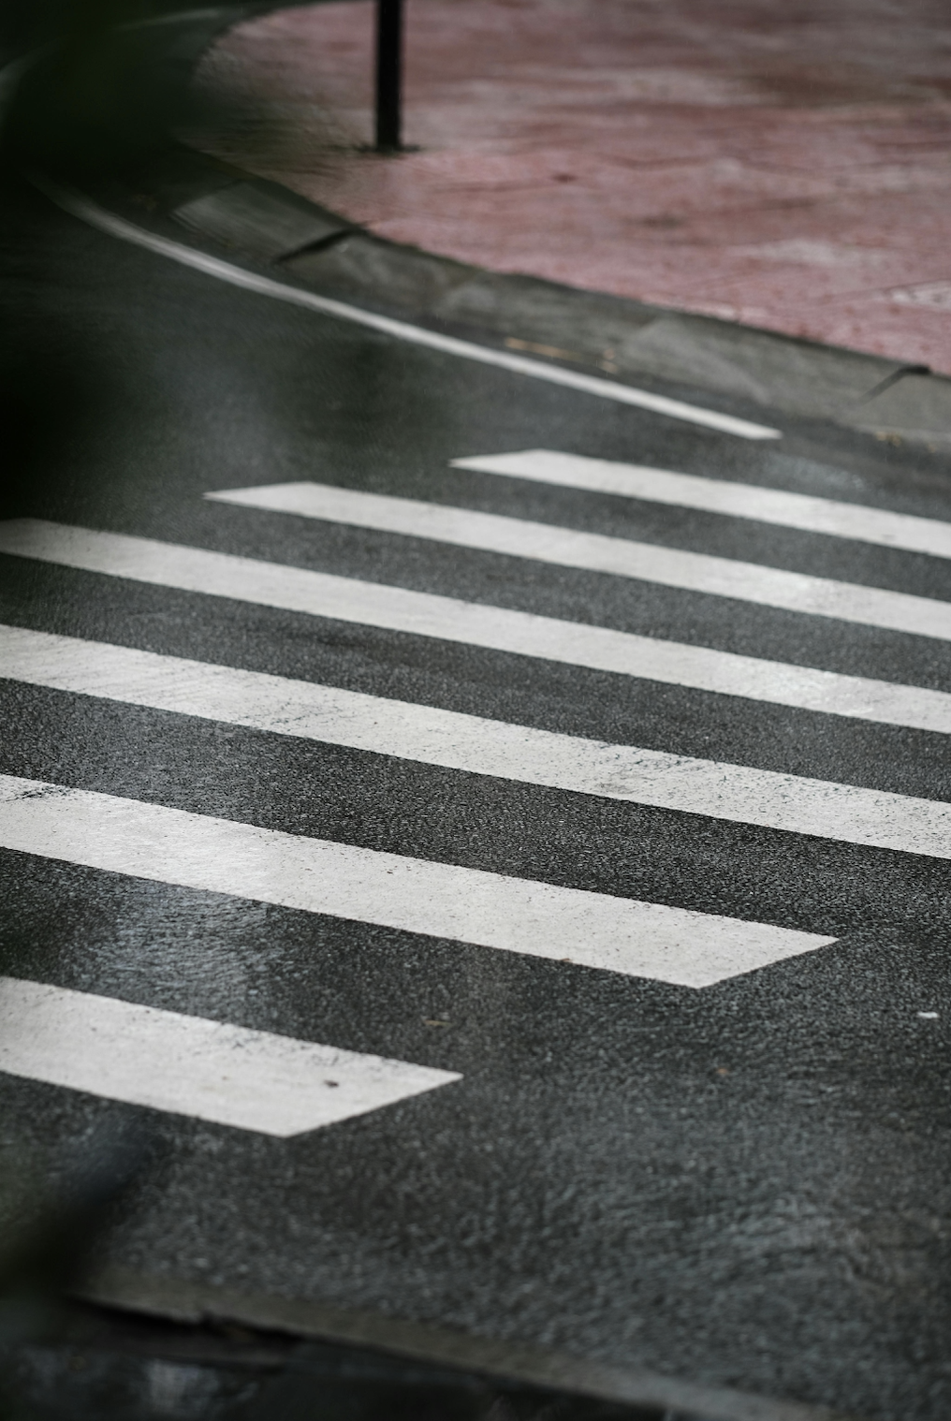

* **Broken White Lines**:
  + Indicate that lane changes are allowed. Signal your intent and ensure the maneuver is safe before crossing.
* **Solid White Lines with Turn Arrows**:
  + These lines indicate turn-only lanes. Follow the arrows to turn in the direction marked.
  + If the lane has both a curved arrow and a straight arrow, you may either turn or proceed straight.

### **Yellow Lines: The Do’s and Don’ts of Opposite Traffic**

* **Broken Yellow Lines**:
  + Allow passing when safe. Stay to the right of the line and return to your lane promptly after overtaking.
* **Double Yellow Lines (One Solid, One Broken)**:
  + Passing is permitted **only** on the side with the broken line.
  + If the solid line is closer to you, crossing is prohibited except for left turns or entering/exiting driveways.

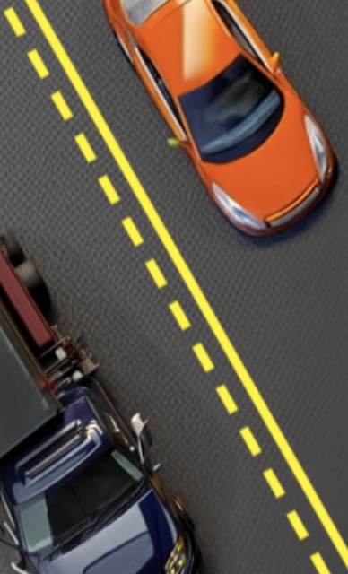

* **Double Solid Yellow Lines**:
  + Passing is strictly prohibited.
  + Crossing these lines is allowed only in specific circumstances, such as:
    - Turning left at an intersection.
    - Entering or exiting a driveway.
    - Driving in a designated carpool lane with an authorized entrance.

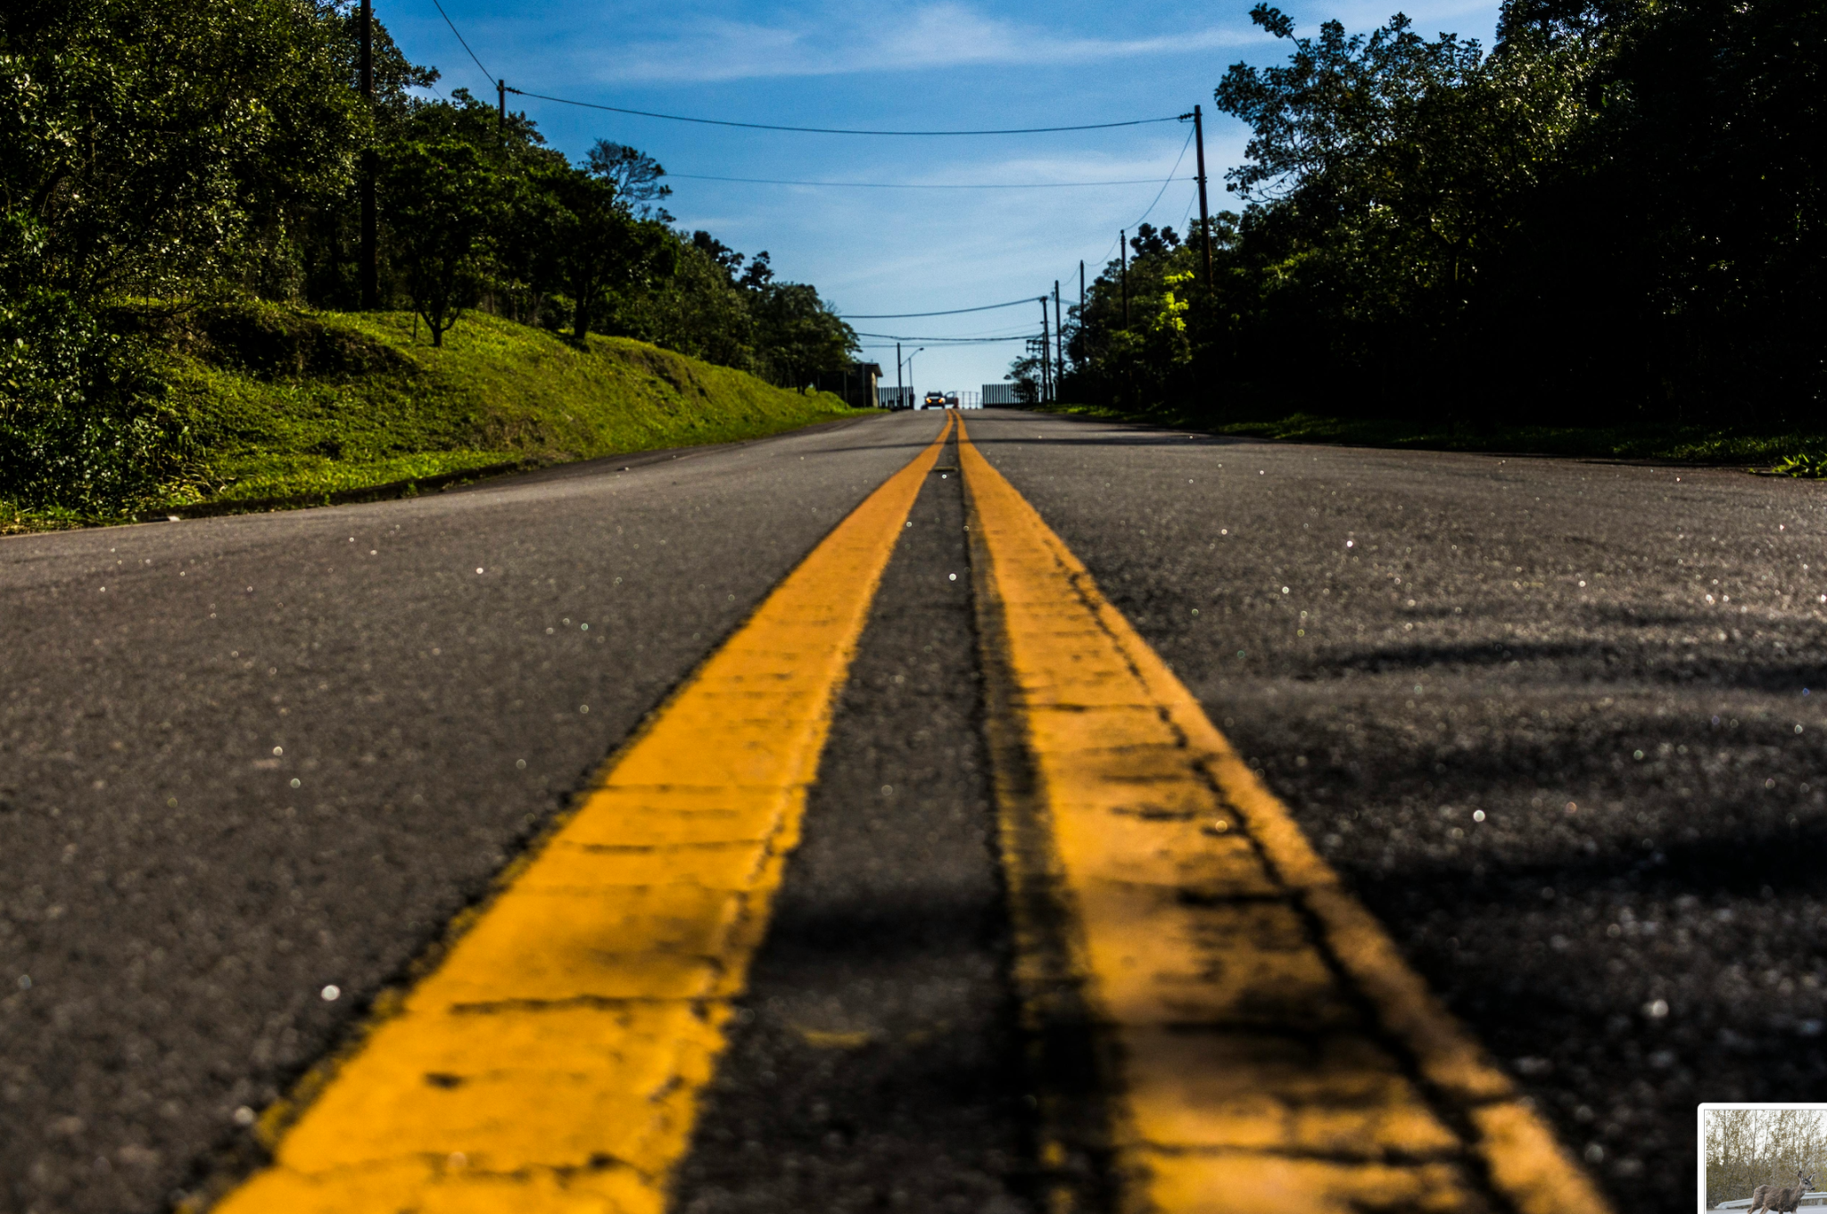

* **Double Yellow Lines as Barriers**:
  + Two sets of double yellow lines spaced two or more feet apart act as barriers.
  + Do not cross or drive over these markings unless at a designated opening.

If you find yourself impatient while driving, and want to disregard lane markings, remember that you are capable of being a calm, patient driver, who follows traffic laws to uphold the safety of everyone on the road. Note how you feel when you drive, and acknowledge the safety risk every time you disregard traffic laws. Ask yourself, is saving a few minutes of time worth the risk of harming myself or others?

### **Center Lanes and Special Markings**

* **Center Left-Turn Lane**:
  + These lanes are specifically for left turns from either direction.
  + Do not travel more than 200 feet in this lane, and never use it for passing.
* **Three-Lane Highways**:
  + The middle lane on a two-way highway may be used for passing, but only when the center line is broken.
  + On a three-lane highway, the center lane is often referred to as a “suicide lane” because vehicles from both directions may enter it, increasing the risk of collisions. Do not use this lane unless it’s explicitly marked for your direction of travel.

### **Understanding Pavement Marking Scenarios**

* **Turn Lanes**:
  + Marked with arrows, these lanes designate safe areas for turning. Always follow the direction indicated by the arrow.
  + Merge into turn lanes early and signal your intent.
* **Special Situations**:

**Bike Lanes**: Marked by a solid white line on the right of the road. Only cross bike lanes when turning or parking, and yield to cyclists.

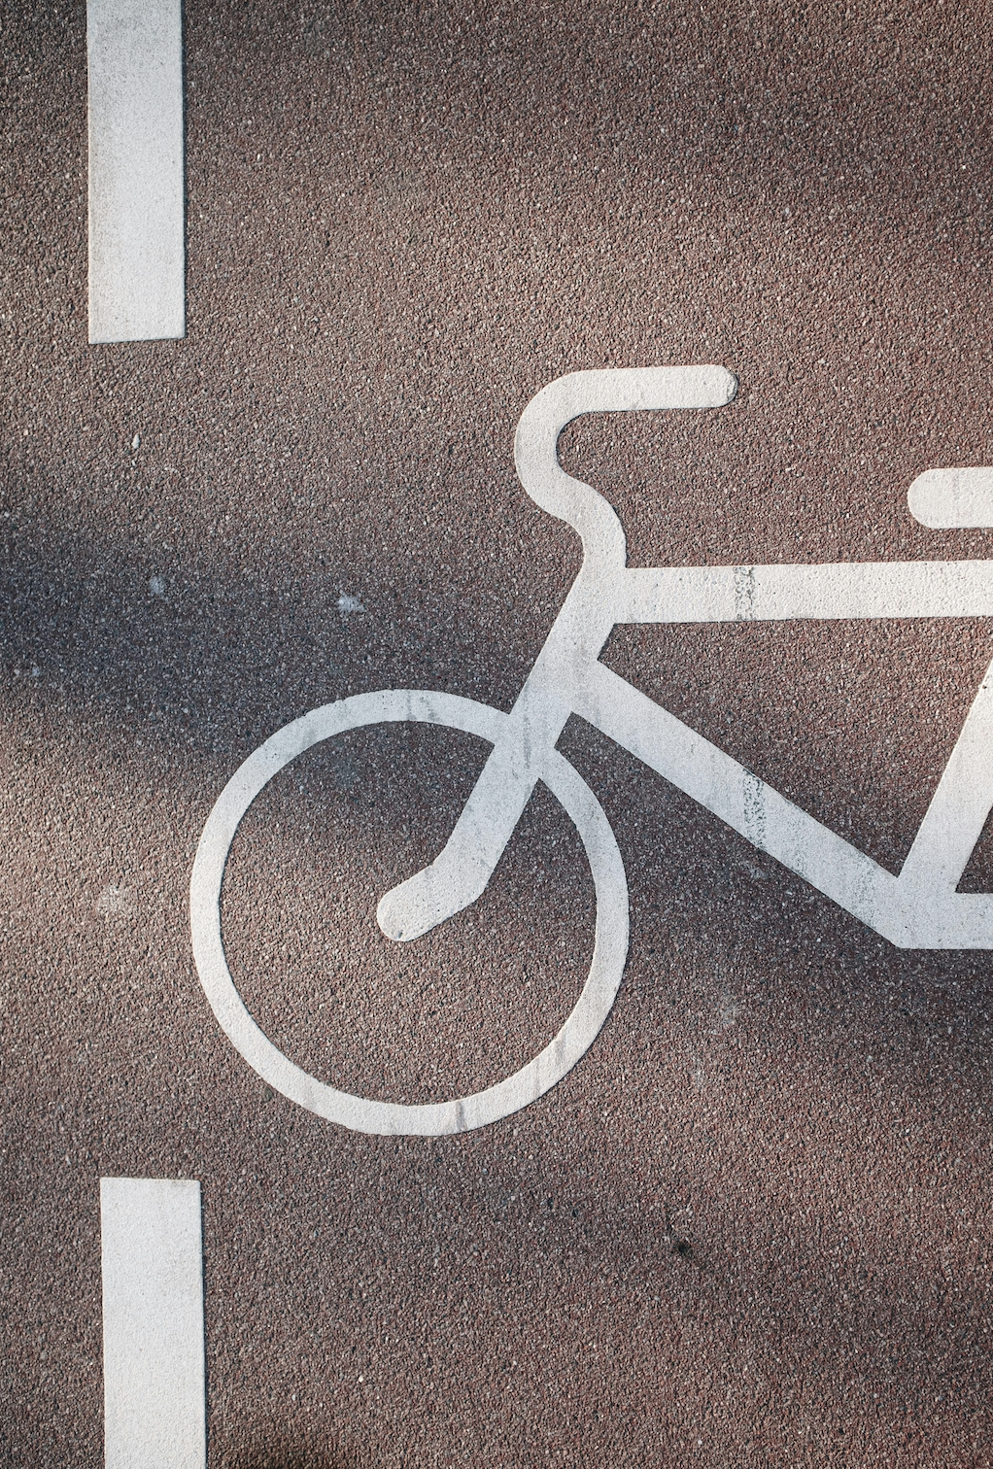

**Construction Zones**: Orange and lime-green markings warn of upcoming construction zones. Sometimes, cones may guide you over lane lines you would normally follow. Make sure you follow the cones. Obey signs, reduce speed, and follow worker instructions. Look for temporary markings like cones or barricades to guide you safely through the area.

### **Why Pavement Markings Matter**

Pavement markings create a visual structure for safe and organized driving. Misinterpreting or ignoring these lines can lead to collisions, fines, or dangerous situations. Stay within your lane, respect markings, and always follow the road’s visual cues. They’re there to keep you and everyone around you safe.

#### **Regulatory Signs**

Regulatory signs provide rules that all drivers must follow under **Florida Statute 316.2061**:

|  | **Stop Sign**: An octagonal red sign requiring a complete stop before the crosswalk, limit line, or intersection. Proceed only when safe. |
| --- | --- |
|  | **Yield Sign**: A triangular sign directing drivers to slow down and yield the right of way to other vehicles and pedestrians. |
|  | **Do Not Enter/Wrong Way**: Red circle signs prohibiting entry, particularly on freeway ramps or one-way streets. Violating these signs is dangerous and can result in severe penalties. |

#### **Warning Signs**

Warning signs alert drivers to potential hazards and changes in the road ahead. These include:

|  | **Pedestrian Crossings**: Indicating areas where drivers must yield to foot traffic. |
| --- | --- |
|  | **Merging Traffic**: Signals where other vehicles will join the current flow. |
|  | **Signal Ahead**: Warn drivers to reduce speed for an upcoming intersection. |
|  | **Stop Sign Ahead**: Warn drivers to reduce speed for an upcoming stop. |

**Scenario: Approaching a Stop Sign or Red Light**

You approach a stop sign or red light with a vehicle behind you. In the past, you might have rushed to avoid holding up traffic or failed to stop completely.

**Desired Behavioral Change:** Patience and adherence to traffic laws.

**CARD – Click To See New Behavior**

Calmly slow down well in advance of the stop sign or red light, coming to a complete stop at the line, and waiting for the signal to change. This helps avoid collisions and demonstrates safe driving.

Make this change when you encounter these traffic devices:

**Stop Sign (Regulatory Sign):** Requires full stop and proper observation for pedestrians and other vehicles.

**Red Traffic Light (Signal):** You must stop and wait for the light to turn green, ensuring you do not risk running a red light.

**Why It’s Important:** Improper stopping or failing to stop at a red light can lead to fines, collisions, or even criminal charges in the case of running a red light (Fla. Stat. § 316.075). Demonstrating patience helps avoid unnecessary conflicts with other drivers.

#### **Railroad and School Zone Signs**

* **Railroad Crossings**: Circular signs with "RR" letters alert drivers to slow down, check for trains, and never stop on the tracks.

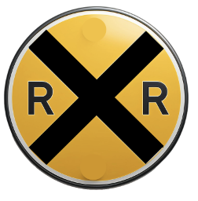

* **School Zones**: Marked by pentagon-shaped signs, often fluorescent yellow-green, requiring reduced speeds and heightened awareness for children.

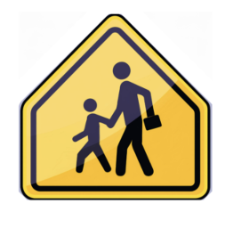

### **Speed Limits**

Adhering to speed limits is crucial for safe and lawful driving. One of the most common traffic offenses is speeding, both in urban areas and highways. In Florida, speed limits vary based on the area and road conditions. This refresher will help you adhere to these rules as you drive in the future:

#### **General Speed Limits**

* **Residential Areas:** 30 mph unless otherwise posted.
* **School Zones:** 20 mph when children are present unless otherwise posted.
* Drivers must adjust speeds for road conditions, traffic flow, and visibility, while avoiding distractions.

### **Florida’s Highway Speed Rules**

On Florida’s limited-access rural highways—like interstates and major expressways—drivers must balance efficiency with safety. The **maximum speed limit** is typically **70 miles per hour**, though it may be lower in certain areas due to traffic density or design. The **minimum speed** is usually around **50 miles per hour**, ensuring that vehicles don’t impede the normal flow of traffic. Drivers are also required to adjust their speed based on weather, visibility, and road conditions. Even if the posted limit says 70, heavy rain, fog, or construction zones may legally require slower speeds. Remember: the safest speed is not always the fastest—it’s the one that gives you enough time to react, control your vehicle, and protect everyone sharing the road.

#### **Specific Speed Limit Zones**

* **Railway Grade Crossings:** 15 mph applies if the view of the crossing is obstructed within the last 100 feet, requiring visibility of 400 feet in both directions. Exceptions include crossings monitored by a human flagman or functioning traffic signals.
* **Highway Intersections:** 15 mph applies if the view of the intersection is obstructed within the last 100 feet, unless stop signs, yield signs, or traffic signals are in place.
* **Alleys:** The speed limit in alleys is 10 mph unless posted otherwise (**FS 316.1945**).

### **Intersection Safety**

Intersections—points where roads meet—are high-risk areas due to the mix of vehicles, bicycles, and pedestrians. Always approach with caution, observing all traffic indicators.

#### **Controlled Intersections**

At intersections regulated by signs, signals, or traffic controllers:

* **Crossing:** Ensure there is enough space to pass safely beyond the white line without causing other vehicles to stop. (**FS 316.183**)
* **Turning:** Wait for sufficient space to turn without disrupting traffic flow. Be patient if multiple vehicles are queued.

### **Scenario: Turning Left at a Green Light**

You’re waiting at an intersection to turn left, and the light turns green. You may have previously rushed the turn or not yielded to oncoming traffic, increasing the likelihood of a collision.

**Desired Behavioral Change**: **Caution** and **yielding when necessary**.

**CARD – Click To See New Behavior**

**Wait for oncoming traffic to clear** before completing your left turn, even if you have a green light. Ensure that pedestrians are clear of the crosswalk.

**Related Traffic Control Devices**:

**Green Traffic Signal:** Requires yielding to oncoming traffic and pedestrians before a safe left turn can be made.

**Green Left Turn Arrow**: Gives permission to turn left but requires caution if oncoming traffic or pedestrians are present.

**Yield to Pedestrians**: Yield the right of way to pedestrians at intersections.

**Why It’s Important**: Turning left without ensuring the intersection is clear can cause collisions. Yielding and being patient ensure that you don’t risk a dangerous collision.

#### **Uncontrolled Intersections**

At intersections without STOP or YIELD signs (such as roundabouts):

* Yield to vehicles already in the intersection
* Yield to vehicles on the right when arriving simultaneously. (**FS 316.123**)
* Slow down and prepare to stop. (**FS 316.185**)
* Check for oncoming traffic before making a left turn, yielding as necessary.

### **Scenario: Approaching an Intersection with No Traffic Signals**

You approach an intersection without traffic signals, and in the past, you may have proceeded without stopping or yielding to other drivers.

**Desired Behavioral Change**: **Caution** and **yielding when necessary**.

**CARD – Click To See New Behavior**

**Yield to vehicles that are already in the intersection**, and stop if required (e.g., at a stop sign). Only proceed when you have clear visibility and when it is safe to do so.  
  
**Why It’s Important**: Failing to yield in an intersection can lead to **collisions** and **collisions**. Proper yielding prevents collisions and ensures that the flow of traffic remains safe and organized.

**Scenario: Navigating a Roundabout**

You approach a roundabout where you need to yield to traffic already in the circle. In the past, you may have entered the roundabout too quickly or failed to yield properly.

**Desired Behavioral Change:** Yielding the right of way and smooth entry.

**CARD – Click To See New Behavior**

As you approach, yield to traffic in the roundabout and enter only when it is safe. Maintain a safe speed and avoid abrupt lane changes once inside the roundabout.

**Yield Signs:** Indicate that you must yield to traffic already in the roundabout.

**Lane Markings:** Direct the flow of traffic and prevent lane changes within the roundabout.

**Why It’s Important:** Failing to yield in a roundabout can lead to collisions and traffic congestion. Proper yielding keeps the flow of traffic safe and uninterrupted.

### **Yielding the Right of Way**

Understanding and following **right-of-way rules** is essential for preventing collisions and ensuring smooth, respectful traffic flow. Yielding the right of way means allowing another driver, pedestrian, or cyclist to proceed first when required by traffic laws or safety conditions.

In Florida traffic law, right-of-way isn’t something you *have* — it’s something you and others must *give*. The moment a driver begins thinking, *“It’s my turn,”* or *“They’re supposed to stop,”* that mental shortcut becomes a habit that invites collisions.

Florida Statutes (§316.121–§316.130) emphasize that **no driver has the right-of-way**. Each situation depends on courtesy, visibility, and judgment. The law expects drivers to anticipate that others may make mistakes — and to yield when necessary to avoid harm.

Risky driving habits often grow from ignoring that shared responsibility. Let’s look at where they appear most often.

### **Four-Way Stops and Controlled Intersections**

At a four-way stop, many drivers *think* they understand the rules but act based on assumption rather than observation.

**Risky Habits to Identify**

* **Rolling stops:** Treating the stop sign as a pause rather than a complete stop.
* **False starts:** Edging forward before confirming another driver has stopped.
* **“Turn order guessing”:** Assuming the car on the left or right will move next, rather than waiting for clear confirmation.
* **Aggressive acceleration:** Racing to “claim” the intersection after waiting too long.

These habits signal impatience and a desire for control. They also create confusion — the leading cause of intersection collisions in Florida neighborhoods (FLHSMV, 2024).

**Scenario:**At a four-way stop in Ocala, two cars approach at the same time. One driver waves the other through; the second hesitates, then both move — and collide at low speed. The crash report lists the cause as *“failure to yield — driver confusion.”*The habit? Treating courtesy as a substitute for clarity. The safe habit is to pause, make eye contact, and yield until sure the way is clear.

**Left Turns and Oncoming Traffic**

Left-turn crashes are among Florida’s most common intersection collisions. They reveal two dangerous habits: **misjudgment of speed** and **rushing against pressure.**

**Behavioral Warning Signs**

* Turning across traffic with limited time.
* “Beating the gap” when the light turns yellow.
* Assuming oncoming traffic will slow.
* Following another left-turning car blindly through a shared green arrow.

Each of these reflects impulsive thinking — the same mental shortcuts that cause rear-end and side-impact crashes. Under FS 316.122, drivers making a left turn must yield until the path is “immediately hazard-free.” That means *zero* risk, not *reasonable* risk.

**Scenario:**Marcus, running late for work, turned left across a busy intersection just as the light changed. The oncoming car couldn’t stop in time. The crash caused minor injuries but cost Marcus his license for six months and raised his insurance by 80%.

The habit wasn’t lack of knowledge — it was habitual impatience.

**Reflection Prompt**Have you ever turned left on a yellow light to “beat” traffic? What did that moment feel like — and was the few seconds saved worth the risk? What is the safe way to handle that situation?

### **Yielding: Merging, Highways, and Lane Changes**

Merging behavior reveals whether a driver views the road as **shared space** or a **competition.** Florida law (§316.085; §316.081) requires vehicles entering or changing lanes to yield to those already occupying the lane. Yet many drivers treat merging like a test of dominance.

**Risky Habits**

* Speeding up to block someone entering the lane.
* Cutting in without signaling or sufficient space.
* Assuming another driver will slow down to “let you in.”
* Staying in the blind spot of a merging vehicle.
* Ignoring bike lanes: Forgetting that cyclists have the same legal standing as vehicles in most right-of-way cases (FS 316.2065).

Failing to yield when required is one of the most common causes of crashes at **intersections, driveways, and crosswalks**—and can result in **citations**, **points on your license**, or even **serious injuries**.

### **When You Must Yield the Right of Way**

1. **At Stop Signs**
   * Come to a full stop.
   * Yield to vehicles in or approaching the intersection, and to pedestrians in crosswalks.
   * If two vehicles arrive at the same time, the driver on the **left yields** to the one on the **right**.
2. **At Yield Signs**
   * Slow down or stop if necessary.
   * Yield to all traffic and pedestrians already in the intersection or close enough to pose a hazard.
3. **Turning Left at Intersections**
   * Yield to all **oncoming traffic** and pedestrians crossing your path.
4. **Entering a Road from a Driveway or Private Road**
   * Yield to all vehicles and pedestrians on the main road.
5. **At All-Way Stops**
   * The first vehicle to stop goes first.
   * If two stop at the same time, the driver on the **left yields** to the driver on the **right**.
6. **Roundabouts**
   * Yield to traffic **already in the circle**.
   * Wait for a safe gap before entering.
7. **Pedestrians in Crosswalks**
   * Always yield to pedestrians at marked or unmarked crosswalks, especially when turning or at intersections.
8. **Emergency Vehicles**
   * Yield by pulling over to the **nearest curb or edge of the roadway** and stopping until the emergency vehicle has passed.

### **Why Yielding Matters**

Yielding isn’t about giving up your spot—it’s about **preventing crashes** and promoting a **cooperative, predictable driving environment**. Right-of-way rules are designed to reduce confusion and help all road users, including pedestrians and cyclists, stay safe.

### **Quick Tips:**

* **Don’t assume** others will yield to you.
* **Make eye contact** when possible at intersections to ensure others see you.
* **Be extra cautious** in poor visibility or bad weather conditions.

#### **Changing Lanes Near Intersections**

Avoid lane changes near intersections, where other vehicles may merge or turn. This ensures smoother traffic flow and prevents confusion. (**FS 316.081**)

### **Scanning Through Intersections**

Scanning is an important technique to implement in your driving behavior. Committing to scanning for hazards and through intersections will significantly reduce your risk of a collision. When approaching or crossing any intersection:

* Constantly scan for hazards like vehicles, bicycles, or pedestrians.
* Avoid speeding, especially through uncontrolled intersections. (**FS 316.183**)
* Maintain awareness even after entering the intersection.

### **Blind Intersections and Alleys**

**Blind Intersections:** Areas where visibility is less than 100 feet in either direction. Follow these rules:

* **Controlled:** Obey posted speed limits.
* **Uncontrolled:** Limit speed to 15 mph to allow for quick stops. (**FS 316.185**)

**Alleys:** Before entering a roadway from an alley or driveway, drivers must stop at the sidewalk and yield to all pedestrians and approaching vehicles. Failing to do so can result in dangerous collisions or violations of pedestrian right-of-way laws. Florida law prohibits parking or stopping in alleys in a way that obstructs traffic (**FS 316.194**). Drivers must exercise caution and yield to pedestrians and vehicles when navigating alleys, ensuring safety for all users.

Florida's right-of-way rules are governed by statutes including **§316.130** (Pedestrian Traffic Regulations) and **§316.125** (Vehicle Approaching Intersections). These laws establish the responsibilities of drivers in various situations and emphasize yielding to prevent collisions.

By adhering to these rules, drivers contribute to safer roadways and demonstrate respect for other road users. Always prioritize caution and courtesy. Maintain a 15 mph speed limit and remain vigilant for pedestrians or objects crossing your path. (**FS 316.183**, **FS 316.185**)

### **Right-of-Way Rules of the Road**

The rules of the road are designed to ensure safety and order when vehicles and pedestrians encounter each other. These rules clearly indicate who must yield the right-of-way, dictating which party proceeds first and which must wait in a variety of traffic situations. While traffic signals and signs help regulate these interactions, drivers are always legally required to yield when necessary to prevent collisions. Florida law emphasizes the importance of exercising caution, especially to avoid collisions involving pedestrians or other vehicles, regardless of traffic signal status.

#### **Pedestrians**

Drivers must **always** yield the right of way to pedestrians, particularly at intersections and crosswalks where they have the legal right of way. Extra care is required around children, older adults, and individuals with visual impairments, such as those using canes or guide dogs. It is mandatory to come to a full stop and allow pedestrians to cross safely before proceeding.

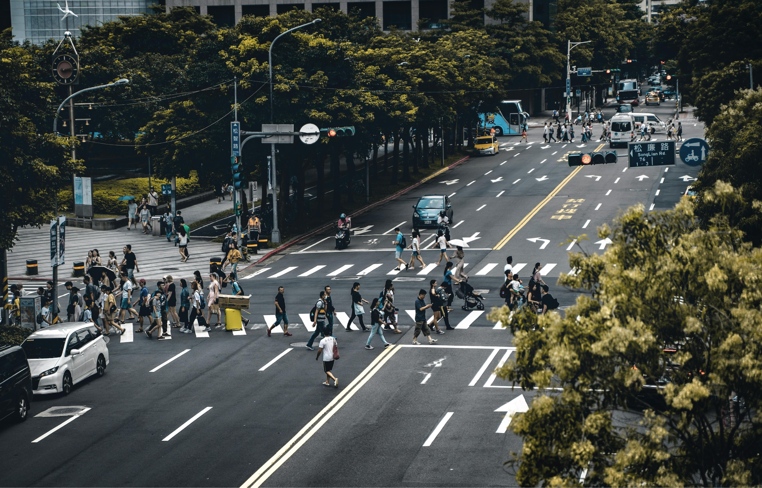

#### **Bicycles**

In Florida, bicycles are legally classified as "vehicles," meaning cyclists share the same rights and responsibilities as motor vehicle operators. Drivers must respect this status and yield to bicycles as they would any other vehicle.

#### **Bicycle Lanes**

Bicycle lanes are marked by white lines and are designated exclusively for cyclists. Motorists may only enter these lanes when parking, turning, or changing lanes, and must always yield to cyclists using the lane. It is crucial to check for cyclists and give them the right-of-way before proceeding.

#### **All-Way Stops**

At an all-way stop, the rule is straightforward: later vehicles yield the right of way to the first vehicle to arrive at the intersection. If two vehicles arrive simultaneously, the vehicle to the right proceeds first. A vehicle making a left turn must yield to all other traffic before proceeding. Additionally, if vehicles are stopped to allow pedestrians to cross, others may proceed only after the pedestrians have safely cleared the roadway.

#### **Uncontrolled Left Turns**

When making a left turn at an intersection without a green arrow or other specific control, drivers are required to yield to all oncoming traffic. Turning should only occur when the path is clear and it is safe to proceed.

#### **Yield Signs**

Yield signs direct drivers to slow down and, if necessary, stop to allow cross-traffic to proceed. Drivers must ensure the intersection is clear before entering.

#### **Changing Lanes and Passing**

When changing lanes or passing, you must yield to vehicles already occupying the lane you wish to enter. It is illegal and unsafe to force another driver to slow down to accommodate your maneuver.

#### **Merging**

Merging onto a roadway requires yielding to all vehicles already traveling in the lane. Never attempt to merge if it forces another driver to adjust their speed or position to accommodate you.

#### **Backing**

When reversing, drivers must yield to all approaching vehicles and pedestrians to avoid collisions. Extra caution is necessary to ensure no pedestrians, especially children, are in the path of the vehicle.

### **Navigating Special Situations**

#### **1. U-Turns**

* **Legal U-Turns**: Allowed at intersections or across double yellow lines unless prohibited.
* **Illegal U-Turns**: Prohibited in business districts, near blind curves, or where “No U-Turn” signs are posted.

#### **2. Construction Zones**

Work zones are marked with diamond or square signs, orange cones, and detour notices. To stay safe:

* **Slow Down:** Follow posted speed limits and worker signals.
* **Yield:** It’s required by law to yield to authorized vehicles and pedestrians in work zones.
* **Pay Attention:** collisions occur when drivers are distracted, ignore directions, or drive aggressively.

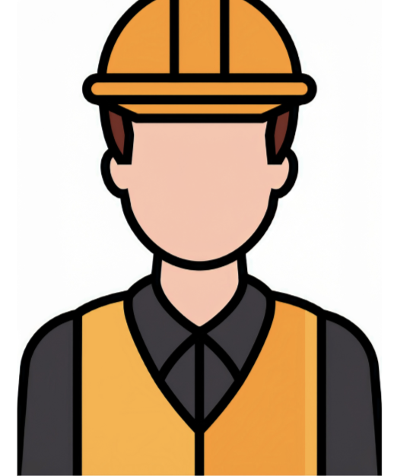

#### **Warning Devices**

Barricades, cones, drums, flashing arrow panels, and markers warn of hazards like uneven pavement, narrow lanes, or heavy equipment. Flashing or steady lights improve visibility at night.

#### **Fines**

Speeding fines are doubled in work zones when workers are present (**FS 318.18**). Drive carefully to avoid penalties and protect everyone on the road.

### **Scenario: Navigating Through Construction Zones**

You’re driving through a construction zone, and traffic is slower than usual. In the past, you might have been frustrated, driven too fast, or disregarded construction signs.

**Desired Behavioral Change**: **Patience** and **compliance with construction zone regulations**.

**CARD – Click To See New Behavior**

**Slow down** and follow the posted speed limit in construction zones. Stay alert for workers, equipment, and changes in traffic patterns, and **avoid lane changes** unless necessary.

**Related Traffic Control Devices**:

**Construction Zone Sign**: Indicates reduced speed limits and the presence of construction activities.

**Lane Closure Markings**: Mark the areas where lanes are closed, helping direct you safely through the zone. Workers may also use cones, lighted signs, or personnel to communicate lane closures.

**Why It’s Important**: Construction zones are often hazardous due to changing road conditions and the presence of workers. Disregarding these signs can result in collisions, fines, and delays (Fla. Stat. § 316.0745).

### **City Driving**

Urban driving involves more vehicles, pedestrians, and distractions than rural areas. Stay safe by following these tips:

* **Follow Traffic Laws:** Obey speed limits, signals, and yielding rules.
* **Be Alert:** Watch for pedestrians and cyclists, especially at crossings.
* **Stay Patient:** Remain calm during rush hour and avoid aggressive driving.
* **Make Eye Contact:** Use eye contact with pedestrians to avoid confusion.
* **Stay Safe:** Everyone benefits when drivers, cyclists, and pedestrians follow the rules.



### **Scenario: Entering or Exiting a Parking Lot**

### You are entering or exiting a parking lot, and in the past, you may have made abrupt or unsafe turns, not checking for pedestrians or other vehicles, or tried to secure a spot by unsafely speeding up.

### **Desired Behavioral Change**: **Slow, cautious entry and exit**. Be patient when you are looking for a place to park.

### **CARD – Click To See New Behavior**

### **Slow down** and be **aware of pedestrians** and other vehicles when entering or exiting the parking lot. Always **use your turn signal** and check your mirrors before making any turns.

### **Why It’s Important**: Unsafe maneuvers in parking lots can result in **collisions** or **damage** to vehicles and people. Cautious driving ensures safety for both drivers and pedestrians.

### **Conclusion**

By mastering the rules of the road, you contribute to a safer, more efficient driving environment. Understanding traffic laws, signals, and markings ensures that you navigate confidently while avoiding collisions and violations. Remember, driving is a privilege that comes with responsibility—make it count.